Oldfield Pond: plantation
Map location and site boundary

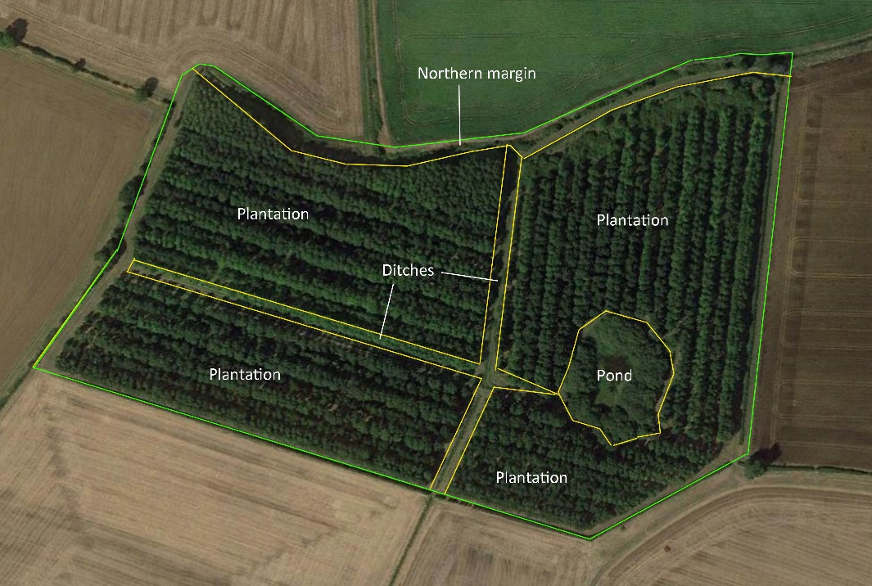

Description  A young plantation, predominantly of broadleaved trees, surrounded by a species-poor hawthorn hedge. Areas of neutral to calcareous grassland are present between the woodland and the hedges, and in more open areas within the woodland. | Features of interest  - Relict neutral to calcareous grassland
Photograph

Technical data

Centre Point Grid Reference: TF13090027
Parish: Castor
Conservation status: none
Data from CPERC: none
Records on NBN: none

The majority of the site is occupied by plantation woodland of Ash and Pedunculate Oak over a ground flora of tall grassland, Bramble and Dog-rose. The dominant shrub species is Hawthorn, but there are occasional bushes of Wayfaring Tree, Hazel and Dogwood. The more mature trees have a dbh of c. 20cm, and there is now some natural regeneration of species such as Pedunculate Oak.

Broad grassy rides are present around the margin of the site, between the woodland and the boundary hedge. There are also areas of grassland within the woodland itself. Much of the peripheral grassland is rather species-poor with abundant Perennial Rye-grass, Yorkshire Fog and White Clover, but within the plantation there are stands of rank unimproved grassland dominated by False Oat-grass, Tor-grass and Tall Fescue with a range of calcareous and neutral grassland indicator species such as Chalk Knapweed, Wild Basil, Lady’s Bedstraw, Agrimony and Ploughman’s Spikenard.

Records were made of 160 species of invertebrates, of which two are nationally scarce and eleven are considered local. They are an interesting mix of species associated with open habitats and with woody vegetation, reflecting the character of the site: uncommon species associated with open grassland remain, but woody vegetation is already sufficiently long-established that four of the six species with formal conservation status recorded are associated with dead wood.

Key plant species recorded

Scientific name | English name | Status | Notes
Agrimonia eupatoria | Agrimony | NGI/CGI
Brachypodium rupestre | Tor-grass | CGI*
Bromopsis erecta | Upright Brome | CGI*
Centaurea debeauxii | Chalk Knapweed | NGI/CGI
Clinopodium vulgare | Wild Basil | CGI*
Galium verum | Lady’s Bedstraw | NGI/CGI
Hypericum perforatum | Perforate St.John’s-wort | CGI
Inula conyzae | Ploughman’s Spikenard | CGI*
Lathyrus pratensis | Meadow Vetchling | NGI
Pulicaria dysenterica | Fleabane | NGI
Rumex acetosa | Common Sorrel | NGI

Key invertebrate species recorded

Scientific name | English name | Status | Notes
Dasytes plumbeus | a false soldier beetle | NS | Habitat mosaics and transitions; larvae believed to develop in dead wood
Platystomos albinus | a fungus weevil | Nb | Fungoid dead wood
Sphecodes ferruginatus | Dull-headed Blood Bee | Nb | Open habitats, especially on calcareous soils
Thereva plebeja | Crochet-hooked Stiletto Fly | N | Open habitats on free-draining substrates
Tiphia minuta | Small Tiphia | Nb | Especially frequent in habitat mosaics and transitions
Uleiota planatus | a flat bark beetle | Na | Under bark of dead standing and fallen broadleaved timber
Xylocoris cursitans | a flower-bug | local | Found under bark, and usually associated with sites with good historical continuity of dead-wood habitats

Key vertebrate species recorded

Scientific name | English name | Status | Notes
Bufo bufo | Common Toad | Section 41 species
Triturus cristatus | Great Crested newt | Sch. 5 species, Section 41 species

Status

The plantation does not qualify as a County Wildlife Site in its own right, but it provides supporting habitat to the pond and ditches, which do qualify. In particular, the terrestrial habitat may be of importance for overwintering amphibians. It is possible that the invertebrate fauna could reach the threshold value for the Invertebrate Index with further recording, but doubtful that they would form a convincing assemblage for CWS status.

Management

The planted woodland is of negligible interest, being relatively young and uniform in structure. The current wildlife interest predominantly lies in the areas of relict unimproved grassland. The wildlife value of the site could be improved by selective removal of trees to eventually provide a more interesting mosaic of grassland, scrub and mature trees.

Associated photographs

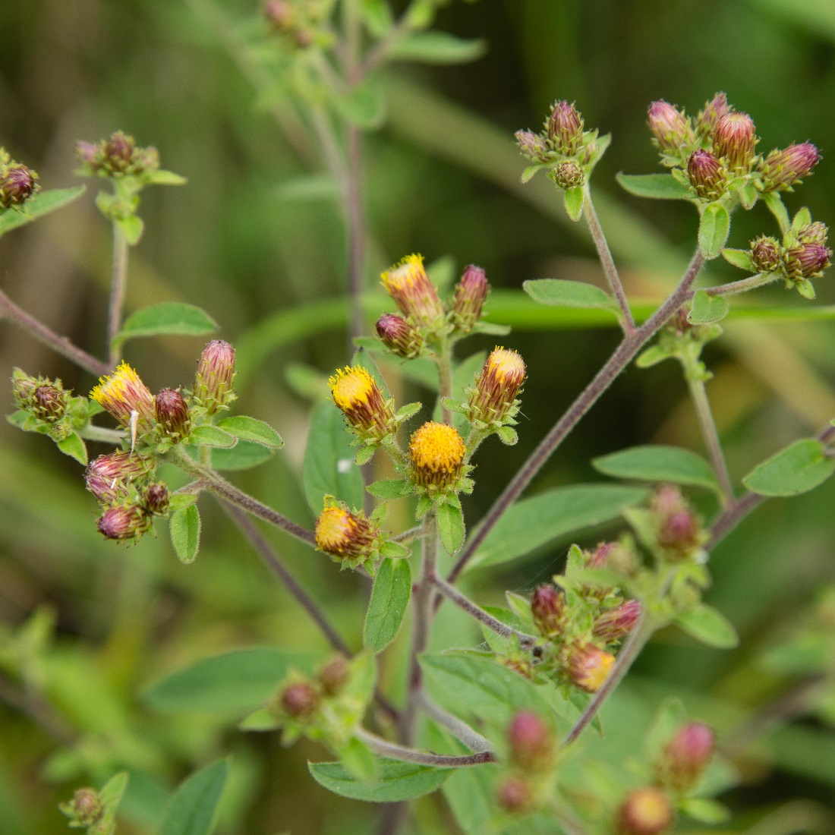
Ploughman’s Spikenard

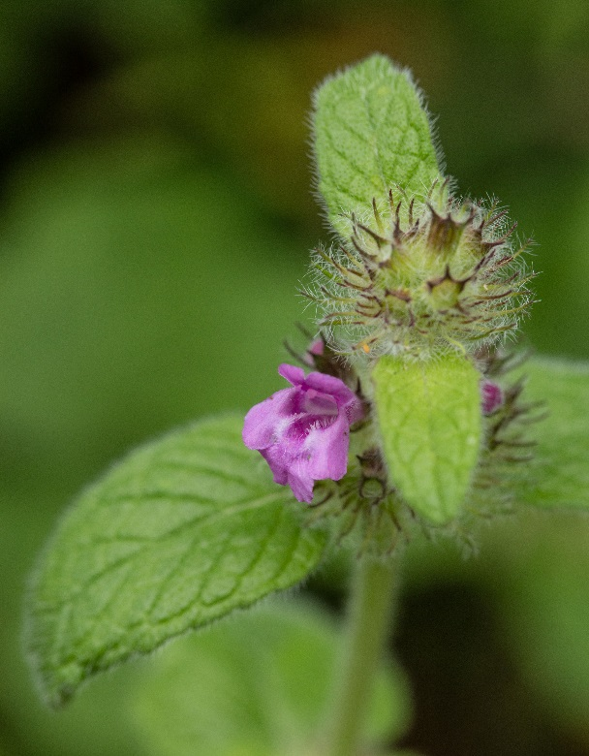  Wild Basil | 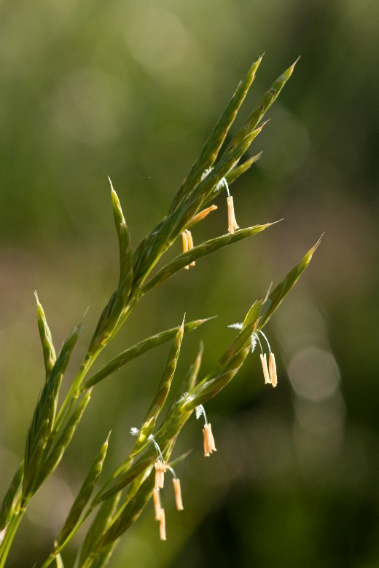  Tor-grass

