Oldfield Pond: summary sheet
Map location and site boundary

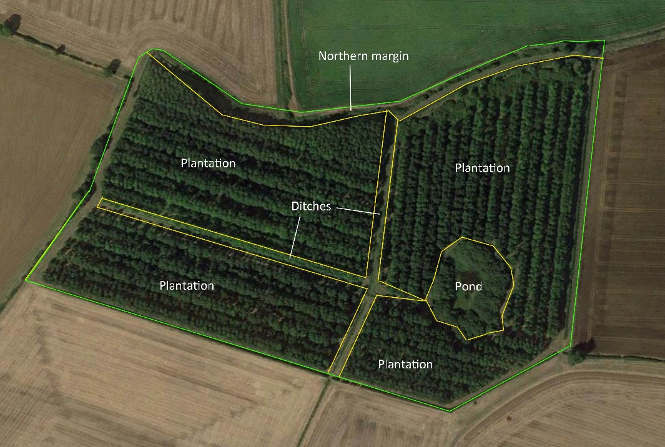

Description  The site consists of plantation woodland, neutral to calcareous grassland, seasonally wet ditches and an ancient field pond with stands of mixed emergent vegetation surrounded by sallow carr. It has been divided into four sub-sites, which are described separately. | Features of interest  - Outstanding assemblage of aquatic invertebrates;  - Species-rich neutral and calcareous grassland  - Local wetland plant species such as Lesser Spearwort, Parsley Water-dropwort and Common Yellow-sedge  - Amphibians including Great Crested Newt and Common Toad
Photographs  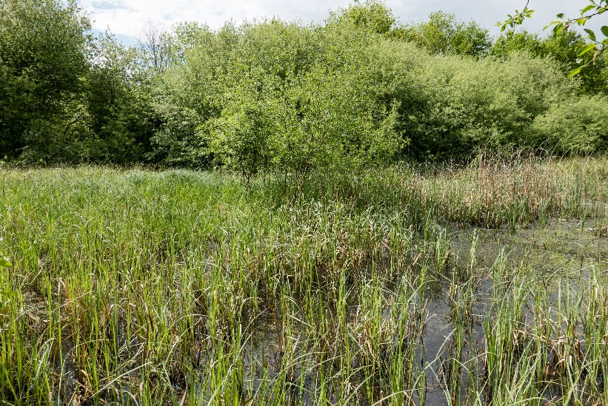 |  | 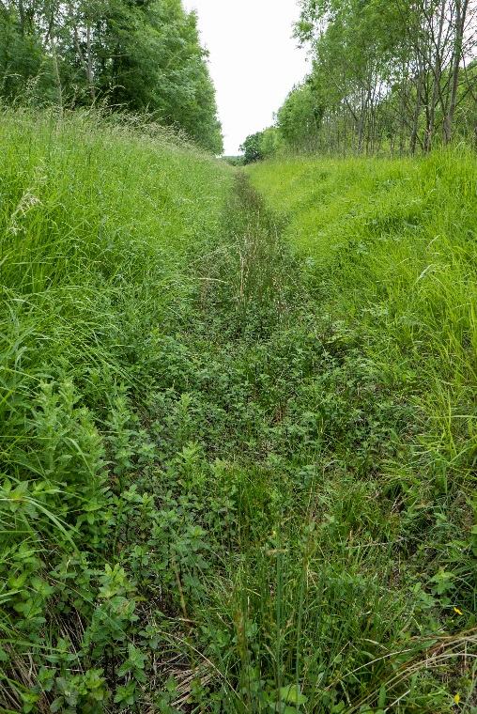

Technical data

Centre Point Grid Reference: TF13090028
Parish: Castor
Conservation status: none
Data from CPERC: yes
Records on NBN: yes

Key plant species recorded

Scientific name | English name | Status | Notes
Agrimonia eupatoria | Agrimony | NGI/CGI
Brachypodium rupestre | Tor-grass | CGI*
Bromopsis erecta | Upright Brome | CGI*
Bromus racemosus | Meadow Brome | NGI*
Carex demissa | Common Yellow-sedge | County rarity | Ditches
Carex flacca | Glaucous Sedge | NGI*/CGI*
Centaurea debeauxii | Chalk Knapweed | NGI/CGI
Centaurium erythraea | Common Centaury | NGI/CGI
Cirsium acaule | Stemless Thistle | CGI*
Clinopodium vulgare | Wild Basil | CGI*
Eleocharis palustris | Common Spike-rush | NGI | Ditches
Galium verum | Lady’s Bedstraw | NGI/CGI
Hypericum perforatum | Perforate St.John’s-wort | CGI
Knautia arvensis | Field Scabious | NT Eng, CGI
Inula conyzae | Ploughman’s Spikenard | CGI*
Lathyrus pratensis | Meadow Vetchling | NGI
Linum catharticum | Fairy Flax | NGI*/CGI*
Lotus corniculatus | Bird’s-foot Trefoil | NGI/CGI
Oenanthe lachenalii | Parsley Water-dropwort | County Rarity | Ditches
Pimpinella saxifraga | Burnet Saxifrage | NGI/CGI
Pulicaria dysenterica | Fleabane | NGI
Ranunculus flammula | Lesser Spearwort | NT Eng, NGI* | Ditches and pond
Rumex acetosa | Common Sorrel | NGI
Samolus valerandi | Brookweed | Local | Ditches
Trisetum flavescens | Yellow Oat-grass | NGI/CGI

Key invertebrate species recorded

Scientific name | English name | Status | Notes
Agabus labiatus | a diving beetle | NT | A declined and relic species of shallow, often seasonal, standing waters
Anthracus consputus | a ground beetle | NS | Plant litter and damp ground at water margins
Badister dilatatus | a ground beetle | NS | Dense vegetation at water margins and fluctuating swamps
Bembidion fumigatum | a ground beetle | NS | Tall marginal vegetation and fluctuating swamps
Berosus luridus | a scavenger water beetle | NT | Well-vegetated pools and drains, often on peat
Calligypona reyi | a planthopper | RDBK | Club-rushes
Ceratocombus coleoptratus | a jumping ground bug | local | Permanently damp plant litter
Chrysolina herbacea | a leaf beetle | local | The foodplant is Water Mint; a scarce species locally, though more frequent further south and west along the Nene valley.
Cicadula flori | a leafhopper | Nb | Marshes and water margins, usually on sedges
Cistogaster globosa | a bristle fly | RDB1 | Moderate to tall lightly managed dry grassland
Colobaea punctata | a snail-killing fly | N | Open-structured vegetation on seasonally exposed fringes of water bodies
Dasytes plumbeus | a false soldier beetle | NS | Habitat mosaics and transitions; larvae believed to develop in dead wood
Donacia cinerea | a reed beetle | NS | Lesser bulrush emergent from still water
Dryops similaris | a long-toed water beetle | NS | Sunny but well-vegetated or mossy margins of ponds and drains
Dytiscus dimidiatus | King Diving Beetle | NT | Ponds and drains, especially with good mollusc populations and in areas of old wetland
Enochrus quadripunctatus | a scavenger water beetle | NS | Well-vegetated but sunny shallow waters and pond fringes
Graptodytes bilineatus | a diving beetle | NS | Well-vegetated shallow ponds and drains, including reed-beds and highly seasonal mossy pools
Graptodytes granularis | a diving beetle | local | Well-vegetated clean waters
Helophorus nanus | a scavenger water beetle | NS | Densely vegetated water margins and swamp, often amongst tall vegetation
Hesperocorixa moesta | a water boatman | local | Clean, well-vegetated shallow pools and drains; characteristic of oligotrophic but calcareous water
Holocentropus stagnalis | a caddisfly | NS | Densely vegetated shallow waters
Hygrotus decoratus | a diving beetle | NS | Well-vegetated base-rich pools
Ilybius chalconatus | a diving beetle | local | Well-vegetated, shallow, often seasonal pools
Linnaemyia rossica | a bristle fly | local | Open habitats and transitions; a predominantly northern and western species
Lygus pratensis | a plant bug | RDB3 | Open habitats with flowering tall herbs; status in need of revision
Nemotelus pantherinus | Fen Snout soldierfly | local | Wet grassland and pond fringes
Nemoura dubitans | a stonefly | local | Shallow water in well-vegetated habitats, such as seepages feeding through sedge or reed-beds
Notaris scirpi | a weevil | Nb | Tall wetland vegetation at water margins and in fluctuating swamps
Pherbellia dorsata | a snail-killing fly | N | Moderate to tall vegetation on seasonally exposed sediments by water bodies
Philonthus fumarius | a rove beetle | Nb | Dense, tall fluctuating swamp
Picromerus bidens | spiked shieldbug | local | Tall herbaceous vegetation in sheltered damp places, especially sheltered wetland transitions
Platystomos albinus | a fungus weevil | Nb | Fungoid dead wood
Sphecodes ferruginatus | Dull-headed Blood Bee | Nb | Open habitats, especially on calcareous soils
Stratiomys potamida | Banded General soldierfly | N | Shallow well-vegetated, sometimes seasonal water in ponds and slow drains, and seepages, often somewhat shaded
Telmatophilus brevicollis | a silken fungus beetle | RDB3 | Tall wetland vegetation
Thereva plebeja | Crochet-hooked Stiletto Fly | N | Open habitats on free-draining substrates
Thrypticus nigricauda | a long-footed fly | NS | Tall wetland vegetation, especially club-rushes
Tiphia minuta | Small Tiphia | Nb | Especially frequent in habitat mosaics and transitions
Uleiota planatus | a flat bark beetle | Na | Under bark of dead standing and fallen broadleaved timber
Xylocoris cursitans | a flower-bug | local | Found under bark, and usually associated with sites with good historical continuity of dead-wood habitats

Key vertebrate species recorded

Scientific name | English name | Status | Notes
Bufo bufo | Common Toad | Section 41 species
Triturus cristatus | Great Crested Newt | Sch. 5 species, Section 41 species

Status

Oldfield Pond qualifies as a County Wildlife Site on the following criteria:
- A Type 10A water body containing more than 15 submerged, floating and emergent species
- Site supports frequent numbers of eight or more neutral grassland indicator species (strong and weak)
- Site supports more than 0.05ha of CG4/CG5 calcareous grassland
- Site supports populations of species which occur in three or fewer sites in the county (VC32) (Common Yellow-sedge and Parsley Water-dropwort).
- An invertebrate index exceeding 500 (1850)
- A significant population of an RDB or NS species (Agabus labiatus), possibly the only county site)

The pond qualifies as a BAP Priority Pond under the following criteria:
- Criterion 2 (species of High Conservation Importance): Pond supports a Schedule 5 species (Great Crested Newt)
- Criterion 2 (species of High Conservation Importance): Pond supports at least one Red Data Book invertebrate species; pond supports more than three nationally scarce invertebrate species

